**Title (Font size 14)**

**First author1, Second author2, ………… (Font size 12)**

*1 Affiliated Institution*

*2 Affiliated Institution*

***\*Corresponding author: Name (email address)***

[Date of Submission: Date of Acceptance: (Used for Conference Organizing Team only)]

**Abstract (Font size 12)**

[Abstract should be finished between 200-250 words in a single paragraph. This section should not contain any table or figure.] (Font size 11)

***Keywords:*** (at least 5 keywords, maximum 7) e.g., GeoMundus; Geospatial; Intelligence; Sustainability

**1 Introduction**

[These days, the whole world is experiencing a wide range of climate-induced challenges resulting in huge losses and damages (Acosta et al., 2016). With a view to reducing losses and damages, sustainable environmental management is crucial (Boda et al., 2021). …………………….] (Font size 11)

**2 Study Area**

**3 Methodology**

**3.1 Sub-section of methodology (Font size 12)**

**3.2 Subsection of methodology……………**

[The following Eq. 1 is used for calculating the Normalized Difference Vegetation Index (NDVI) followed by Nomura and Oki (2021).

…………………………………………………………………………………. (1)



Where NIR means near-infrared spectrum and RED indicates the red range of the spectrum.] (Font size 11)

**4 Results**

[Figure 1 shows the logo of the 15th GeoMundus Conference that will be held in Castellon de la Plana, Spain on 20-21 October 2023. Table 1 illustrates some agenda of the conference.] (Font size 11)

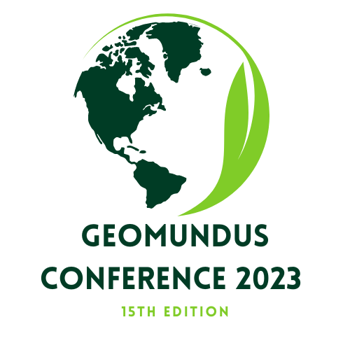

Figure 1: Logo of the 15th GeoMundus Conference (Font size 10)

Table 1: Some of the conference agenda (Font size 10)

| **SL** | **Agenda** | **Date** |
| --- | --- | --- |
| 1 | City tour | 19th of October |
| 2 | Opening Ceremony | 20th of October |
| 3 | Workshop | 21st of October |

*Note: The full schedule is available on the website* [Footnote; font size 9 and Italic]

**4.1 Sub-section of results (if needed)**

**4.2 Sub-section of results (if needed) ……………**

**5 Discussion**

**6 Conclusion**

**Acknowledgment**

**References**

Acosta, L. A., Eugenio, E. A., Macandog, P. B. M., Magcale-Macandog, D. B., Lin, E. K. H., Abucay, E. R., ... & Primavera, M. G. (2016). Loss and damage from typhoon-induced floods and landslides in the Philippines: community perceptions on climate impacts and adaptation options. *International Journal of Global Warming*, *9*(1), 33-65.

Boda, C. S., Faran, T., Scown, M., Dorkenoo, K., Chaffin, B. C., Nastar, M., & Boyd, E. (2021). Loss and damage from climate change and implicit assumptions of sustainable development. *Climatic Change*, *164*, 1-18.

Nomura, R., & Oki, K. (2021). Downscaling of MODIS NDVI by using a convolutional neural network-based model with higher resolution SAR data. *Remote Sensing*, *13*(4), 732.

**General instructions:**

1. The font style for the whole manuscript should be “Times New Roman”
2. If it is necessary to use an abbreviation, please mention the full form of the abbreviation (e.g., NDVI - sub-section 3.2).
3. Bullet points should be avoided in the manuscript.
4. The font size of the manuscript’s title is 14.
5. The font size of all headings is 12.
6. The font size of the content under all headings is 11 (except for figure and table)
7. The font size of the figures caption is 10 (Figure 1).
8. The font size of the content and the caption of the tables is 10 (Table 1).
9. The font size of the footnote is 9 and the style is Italic (Footnote of Table 1).

**Please do not change the style of the template and follow the instructions!**